Microsoft Defender XDR

Extracted from [here](https://www.youtube.com/watch?v=fbg0bN2v960&list=WL&index=16&t=40s&pp=gAQBiAQB):

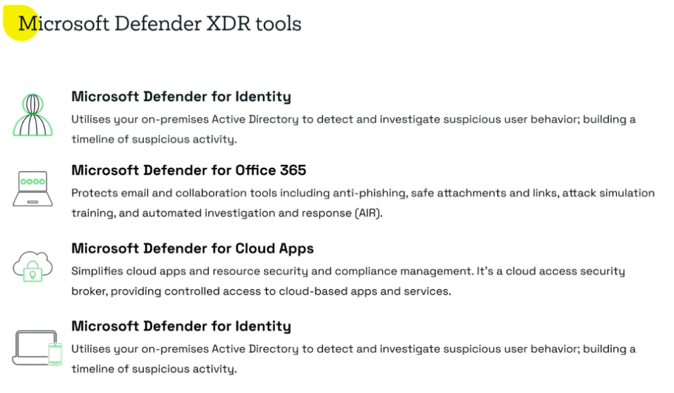

Last one is defender for endpoint.

Defender for office 365 is mainly around email protection.

Microsoft do have sandboxes engines and investigative services to discover malicious urls, but attackers use time delay method to avoid initial screening but later execute to avoid this Microsoft have Zap.

Defender for cloud support controls like user signing up for services that don tuse data protextion techniques like multifactor auth or ssl, or user shipping their data to drive or external cloud files. Cloud apps is also use for cases where defender endpoint is not applicable like unmanaged devices or IoT their cloud defender could be used.